SIMATS ENGINEERING
ASSESSMENT TOOL 2

NAME: SIVARANGJENII B
REG NO:192521375
COURSE NAME: COMPUTER NETWORKS
COURSE CODE: CSA07

COURSE OUTCOME COVERED

CO5: Measure network performance using key metrics with simulation tools. (BL4,BL5)

Assessment Tool Weightage: 30%

Annexure A

Pseudocode Writing Task (Algorithm Design)

- In a network simulation using Cisco Packet Tracer, a student records total data received as 8000 bits in 4 seconds and observes that 200 packets were sent while 180 packets were received. Write a pseudocode algorithm to calculate the network throughput in bits per second and the packet loss percentage based on the given values. The algorithm should include validation to ensure that time and total packets sent are not zero to avoid errors. It should display both the throughput and packet loss results clearly. Add logic to classify the network as Efficient if throughput is greater than 1500 bps and packet loss is less than 10%, otherwise classify it as Inefficient. Finally, ensure the algorithm outputs a complete summary of the network performance based on the calculated metrics.
- An organization has multiple network links connecting its branches. The administrator wants to monitor bandwidth utilization and identify overloaded links. Write a pseudocode algorithm that periodically collects the bandwidth usage of each network link and stores the values in an array or list. Use a loop to continuously monitor all links. Add conditions to detect when bandwidth utilization exceeds 80% and recommend switching traffic to a backup link. Explain how this algorithm supports efficient bandwidth management and prevents network congestion.
- A company has six branch offices connected through multiple network links. Each link has different bandwidth, delay, and utilization values, which change throughout the day. The network administrator wants to continuously identify the best communication path between the headquarters and each branch based on overall link quality rather than just the shortest distance.Write a pseudocode algorithm that periodically collects the bandwidth, delay, and utilization of every network link and stores the values in suitable arrays or lists. Use a loop to repeat the monitoring process at regular intervals. Calculate a link quality score for each path using the collected metrics and select the path with the highest score. Include conditions to detect when a link becomes overloaded or fails, automatically selecting an alternate path and generating an alert for the administrator. Explain how your algorithm improves network reliability, routing efficiency, and fault tolerance while adapting to changing network conditions.

RUBRICS FOR CALCULATION

Criteria | Weightage | Level 4 – Exemplary | Level 3 – Proficient | Level 2 – Developing | Level 1 – Beginning
Problem Understanding | 20% | Identifies all inputs, outputs, constraints accurately | Minor missing elements | Partial understanding | Incorrect interpretation
Algorithm Design | 30% | Complete, correct, and logically sound solution | Minor logical gaps | Partially correct logic | Incorrect approach
Use of Control Structures | 20% | Efficient and appropriate use of loops, conditions, functions/modules | Minor inefficiencies | Limited or basic usage | Incorrect or missing constructs
Pseudocode Structure | 10% | Well-structured, clear, consistent format, easy to follow | Mostly clear with minor issues | Difficult to follow in parts | Poorly structured and unclear
Completeness | 20% | Handles all cases; optimized approach | Handles most cases; reasonable efficiency | Handles basic cases only | Incomplete or inefficient

- Pseudocode: Network Throughput and Packet Loss Calculation

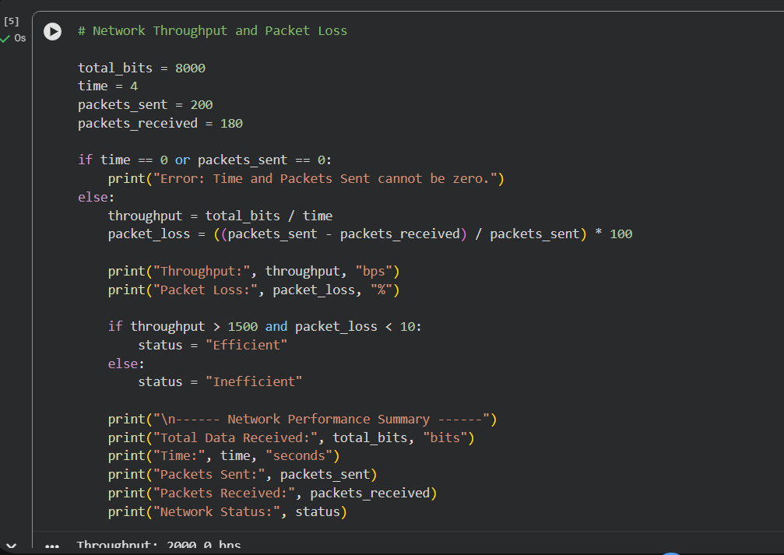

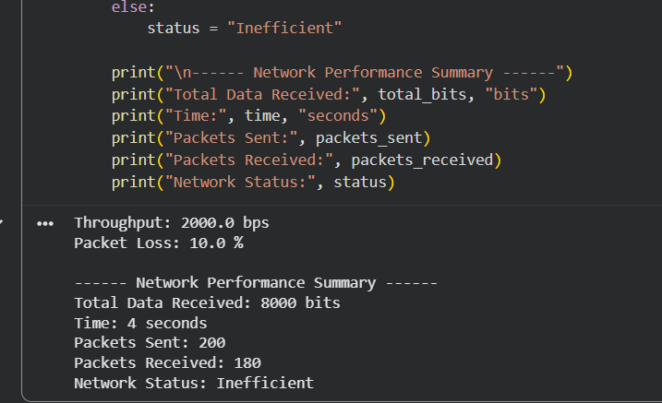

- Pseudocod: Bandwidth Utilization Monitoring

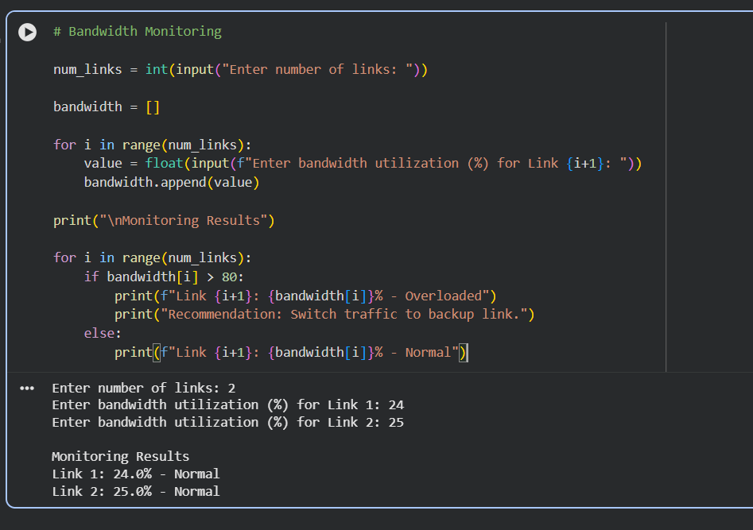

- Pseudocode: Best Path Selection Based on Link Quality
